Copy Paste Tool

Installation Guide

Maciej Szymczak, 2018.07.19

UPGRADE 1

Install package 1

NEW INSTALLATION 1

Install package 1

Install example configuration 1

Setup user access to Copy-Paste Tool 2

Add Copy-Paste Tool to Home Tab/Tab 3

# UPGRADE

## Install package

Use https://workbench.developerforce.com or Migration Tool

|  |
| --- |
| Ant CopyPasteToolUpload |

# NEW INSTALLATION

## Install package

Use https://workbench.developerforce.com or Migration Tool

|  |
| --- |
| Ant CopyPasteToolUpload |

## Install example configuration

This configuration will help you to move the copy paste tool configuration between enviroments.

Run this apex code using developer console:

|  |
| --- |
| Copy_Paste_Tool__c cpt **=** New Copy_Paste_Tool__c**();**  cpt**.**Name**=**'Copy Paste Tool: Excel Template'**;**  cpt**.**Data_Header__c**=**'Name~tab~Data_Header__c~tab~DML_Operation__c~tab~Insert_Null_Values__c~tab~List_Of_Fields__c~tab~Max_Records__c~tab~sObjectName__c~tab~Sync_Field__c~tab~Where_Clause__c'**;**  cpt**.**DML_Operation__c**=**'Upsert'**;**  cpt**.**Insert_Null_Values__c**=**TRUE**;**  cpt**.**List_Of_Fields__c**=**'Name,Data_Header__c,DML_Operation__c,Insert_Null_Values__c,List_Of_Fields__c,Max_Records__c,sObjectName__c,Sync_Field__c,Where_Clause__c'**;**  cpt**.**Max_Records__c**=**100000**;**  cpt**.**sObjectName__c**=**'Copy_Paste_Tool__c'**;**  cpt**.**Sync_Field__c**=**'Data_Header__c'**;**  cpt**.**Where_Clause__c**=**''**;**  insert cpt**;**  Copy_Paste_Tool__c cpt2 **=** New Copy_Paste_Tool__c**();**  Cpt2**.**Name**=**'Copy Paste Tool: External Fields'**;**  Cpt2**.**Data_Header__c**=**'External_Field_Name__c~tab~Field_Name__c~tab~SOQL__c'**;**  Cpt2**.**DML_Operation__c**=**'Upsert'**;**  Cpt2**.**Insert_Null_Values__c**=**TRUE**;**  Cpt2**.**List_Of_Fields__c**=**'External_Field_Name__c,Field_Name__c,SOQL__c'**;**  Cpt2**.**Max_Records__c**=**100000**;**  Cpt2**.**sObjectName__c**=**'CPT_External_Field__c'**;**  Cpt2**.**Sync_Field__c**=**'External_Field_Name__c'**;**  Cpt2**.**Where_Clause__c**=**''**;**  insert cpt2**;** |

## Setup user access to Copy-Paste Tool

* Add Permission Sets to Users (“Copy Paste Tool User” for regular users and “Copy Paste Tool Admin” for Administrators)
* Share configuration with the users

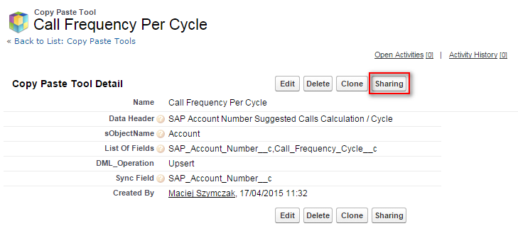

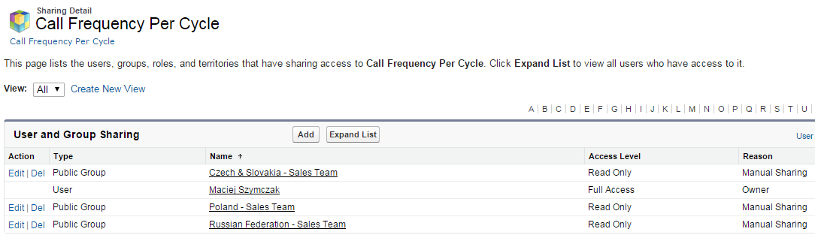

## Add Copy-Paste Tool to Home Tab/Tab

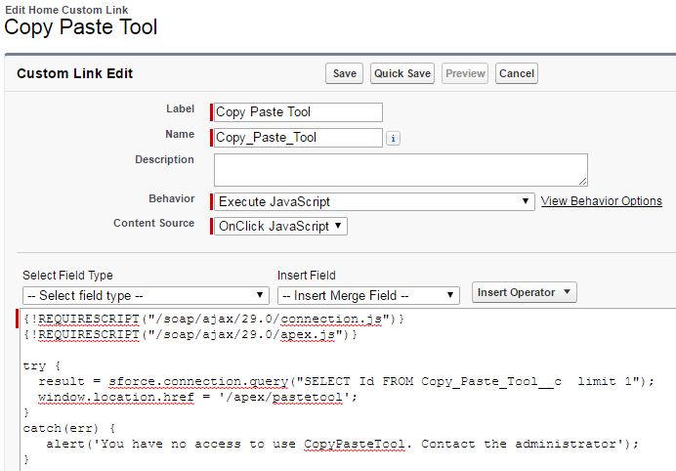

|  |
| --- |
| {!REQUIRESCRIPT("/soap/ajax/54.0/connection.js")}  {!REQUIRESCRIPT("/soap/ajax/54.0/apex.js")}  try {  result = sforce.connection.query("SELECT Id FROM Copy_Paste_Tool__c limit 1");  window.location.href = '/apex/pastetool';  }  catch(err) {  alert('You have no access to use CopyPasteTool. Contact the administrator');  } |

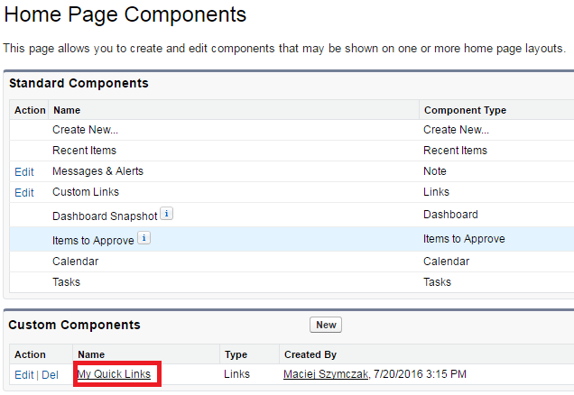

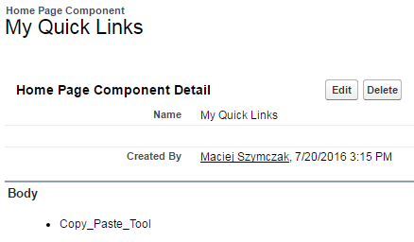

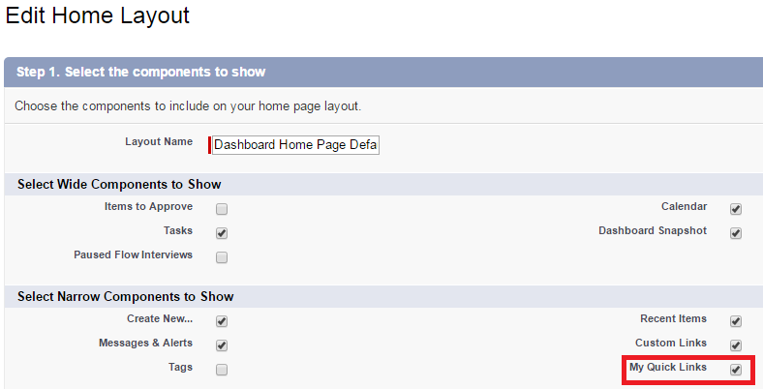

If you don't want expose Copy Paste Tool on Home Page Layout follow below advise:

|  |
| --- |
| **Create a Visual Force tab:** Setup > Tabs > Visual Force Tab > New > Paste Tool  Share the tab with permission Set. |